How to Place Holds in Enterprise

From the search results page, when you have found an item you would like to place on hold, you can use the “Hold Any Copy” button on the right hand side of the result:
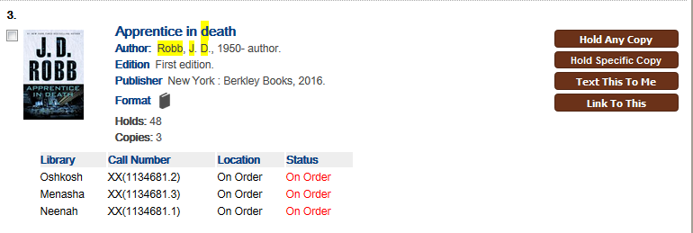

If you are not already logged in, you will be prompted to log in with your library card number and PIN:
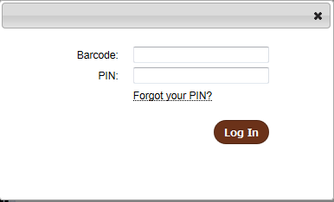

When logged in, the Place Hold confirmation box appears.
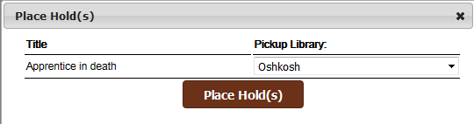

The library set as your Preferred Library in Your Account appears as the default Pickup Library, although you can change it. Click the “Place Hold(s)” button to place your hold.

If the hold was able to be placed, the summary box will show that the hold was successful:
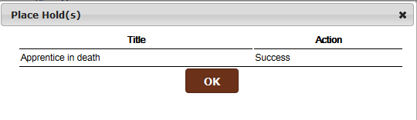

If you are not able to place a hold, the summary box will show that the hold was not allowed:
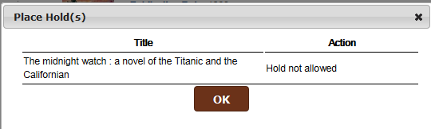

If the hold was successful, it will show up on the Holds tab of your My Account page, where you can view and edit all your current holds.

You can also place a hold by clicking on the item’s title to bring up the detailed information about the item:
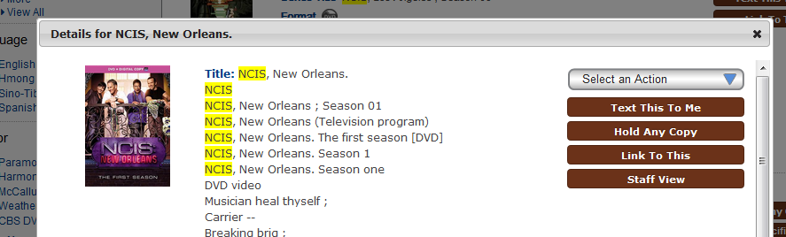

If you would like to hold a particular copy, if you are on the search results page, you can click on the “Hold Specific Copy” button on the left side of the item information:
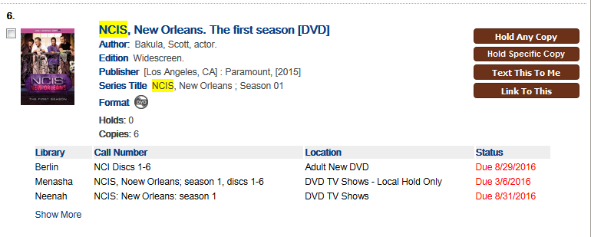

This will take you to a page of the item’s information, and drop you to the list of holdings for the item:
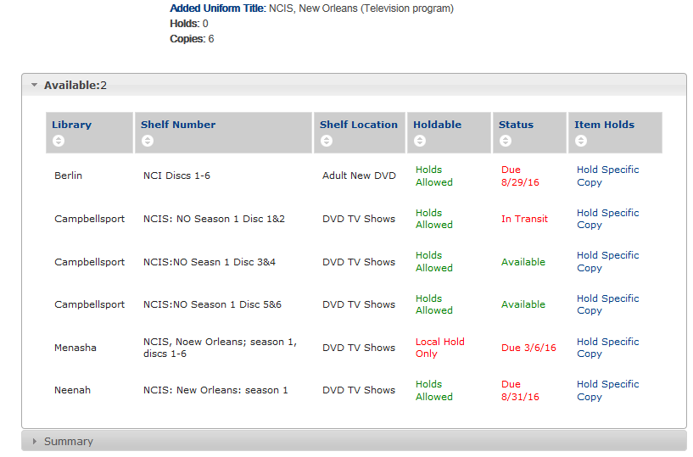
(Scroll up and you will see the title information for the item).
Click on the “Hold Specific Copy” link on the item you would like to place a hold on. For example, clicking on the link indicated by the red box above would place a hold on Campbellsport’s Disc 1 and 2.

You are then prompted to log in if not already logged in, and then will see the same “Place Hold” box as you would if you were placing a hold on any copy:
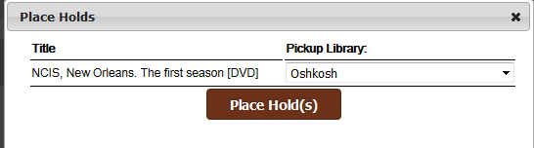
Click “Place Hold” to place the hold. If you look on the Holds tab of your account, you will see the item is on hold for you.

You can return to your search from the page of item information by using the Back button of your browser.

You can also place a specific copy on hold by clicking on the item’s title to bring up the window of information.
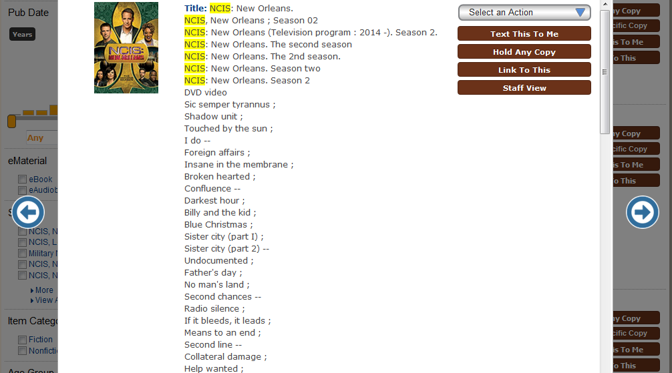
Scroll to the bottom of the item’s information to see which libraries own it item, and the link to hold specific copies of the item.
